# AnimalShelter README

## About the Project: Animal Shelter

This project allows users to access from the AAC database within a web browser. Users can filter the data manually or use built in filters for specific rescue situations. Users can view geolocational data for selected animals and a pie chart breakdown of dog breeds when filters are selected.

## Motivation

The AAC database is used to identify dogs within AAC shelters that may be a good fit for Search and Rescue operations. This program will allow users to quickly access this data and filter it for specific needs, streamlining the client's business processes.

## Getting Started

1. MongoDB must be set up on the device.
2. Python and Jupyter Notebook and Dash must be installed on the device.
3. The AAC database must be downloaded on the device.

## Installation

using the terminal, import the aac_shelter_outcomes.csv file.

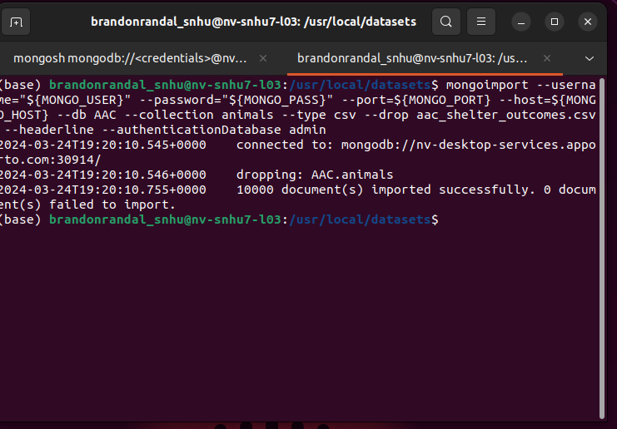After importing the file, a user account needs to be created for the database.

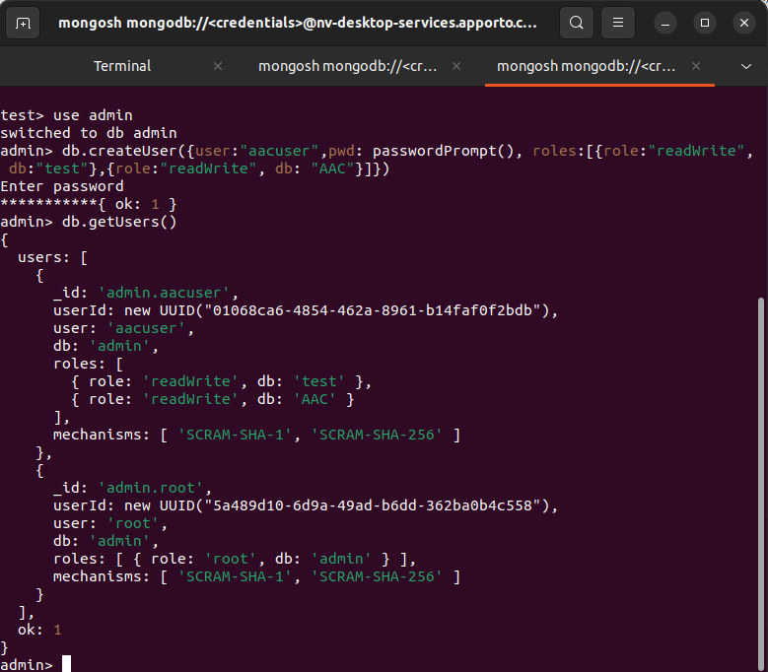

From here you can load the code in Jupyter notebook and run it to access the database.

Ensure this message is displayed then follow the link to access the webpage.

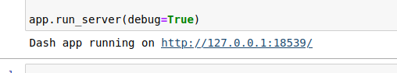

## Usage / Additional Screenshots

Main Screen and default widget view

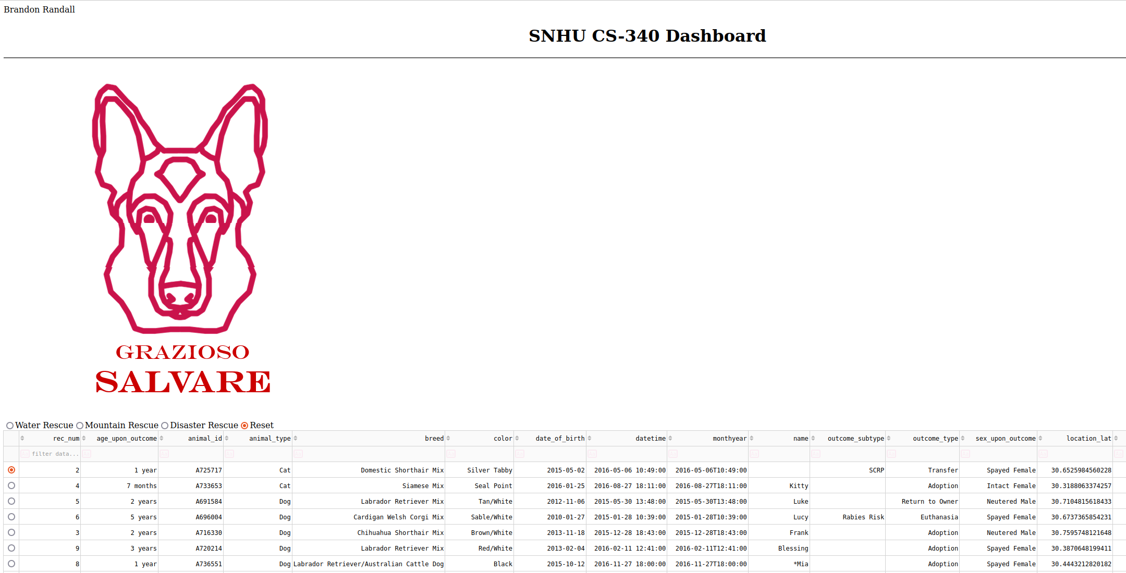

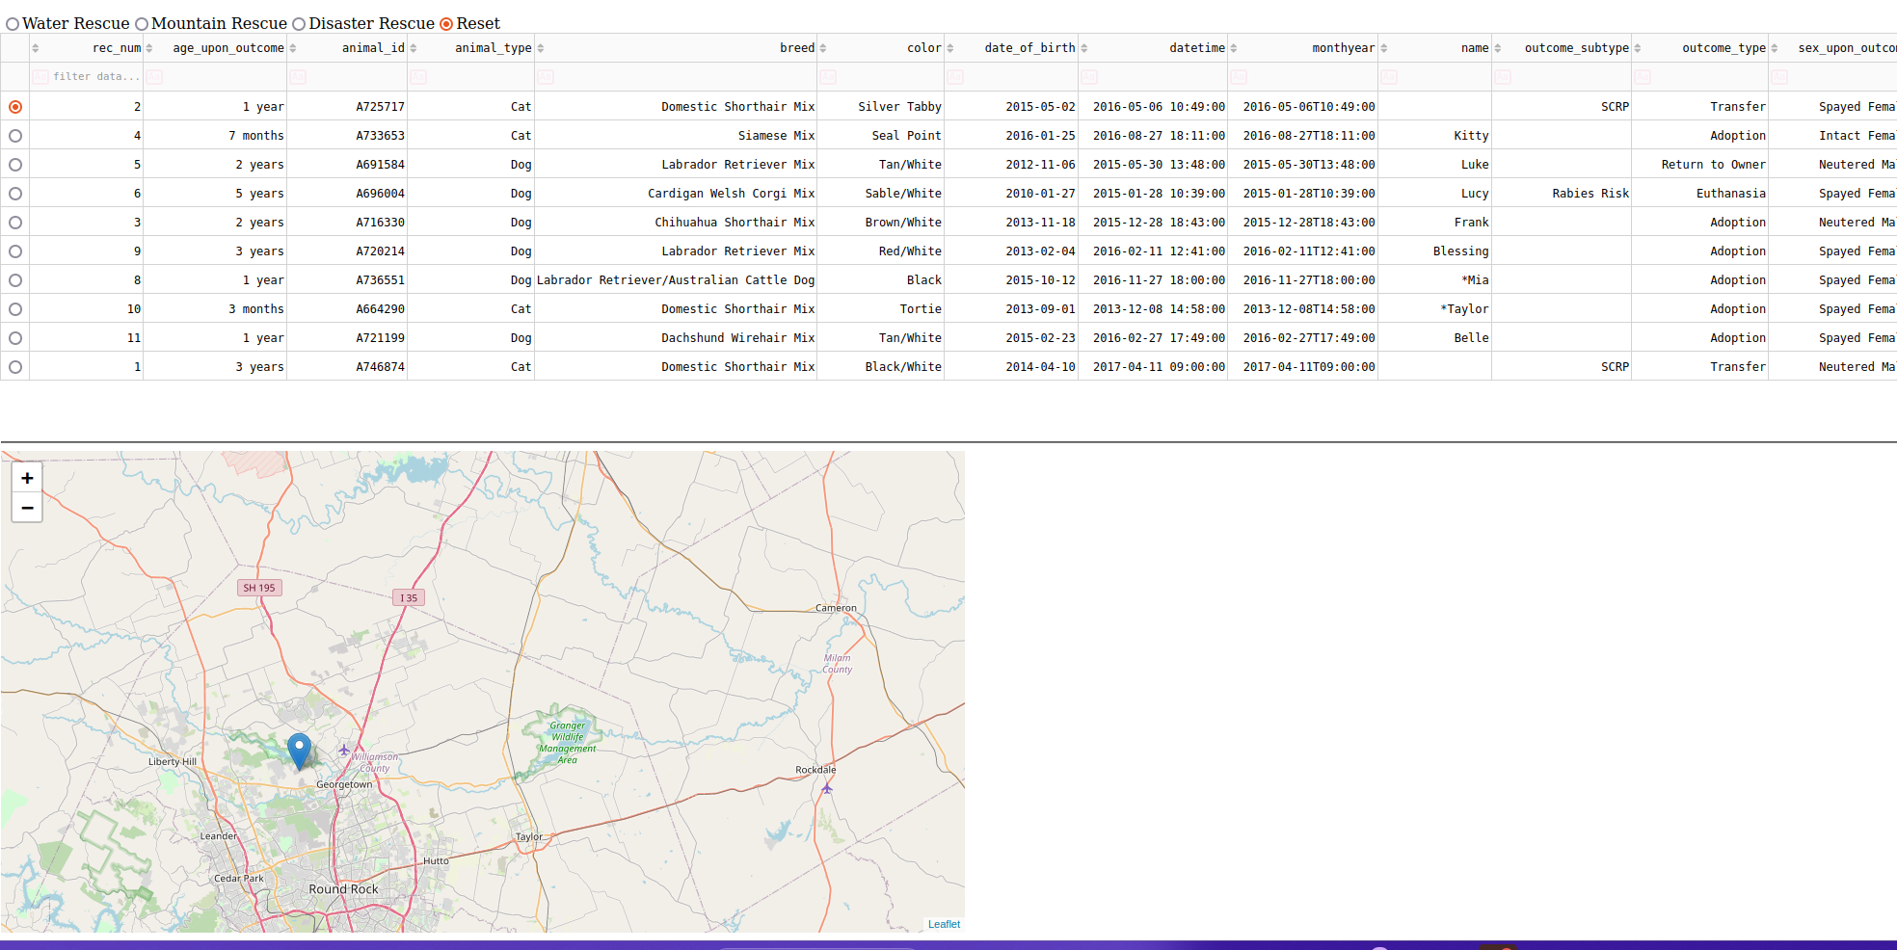Filter Usage

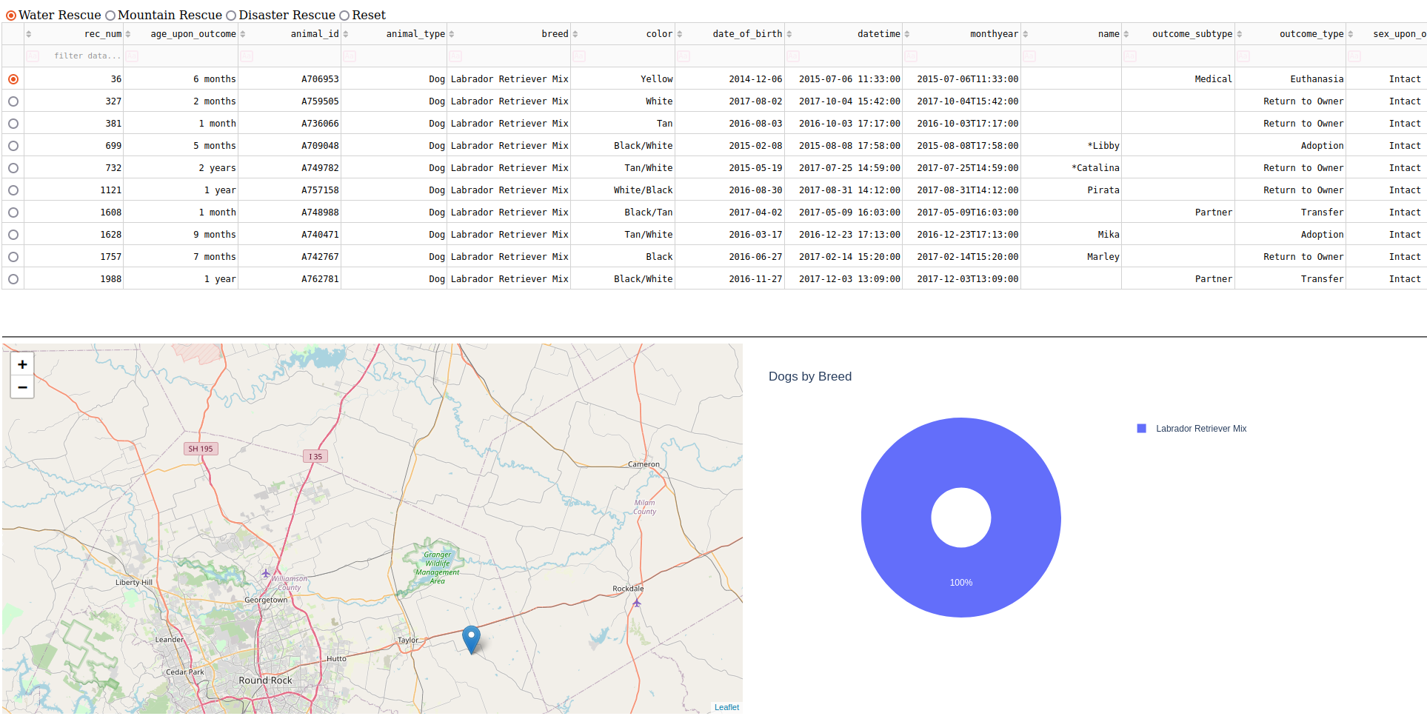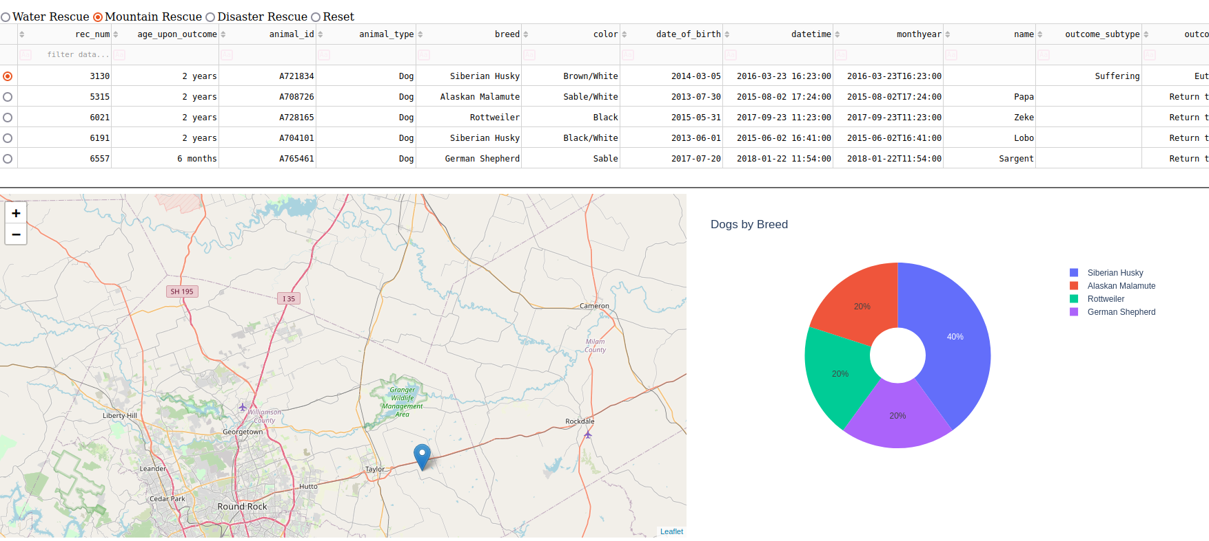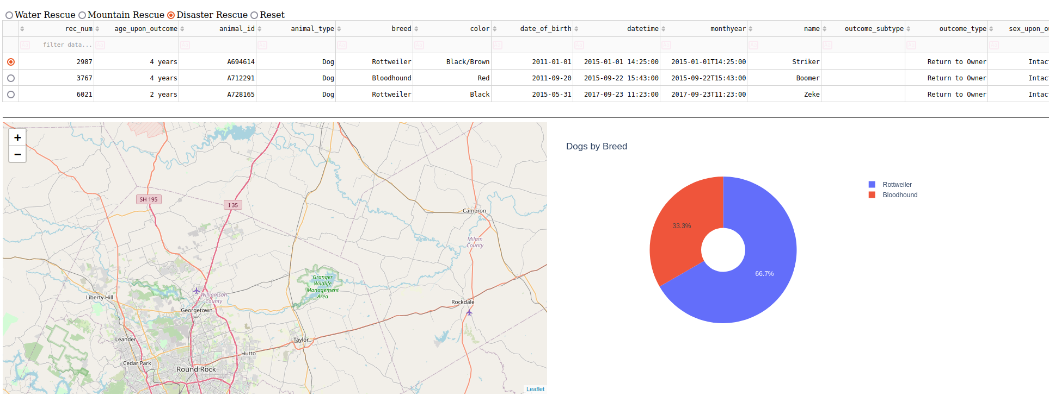The Reset filter will return the program to it’s default view.

The Pie chart is not displayed during the default view due to the amount of data causing visual issues.

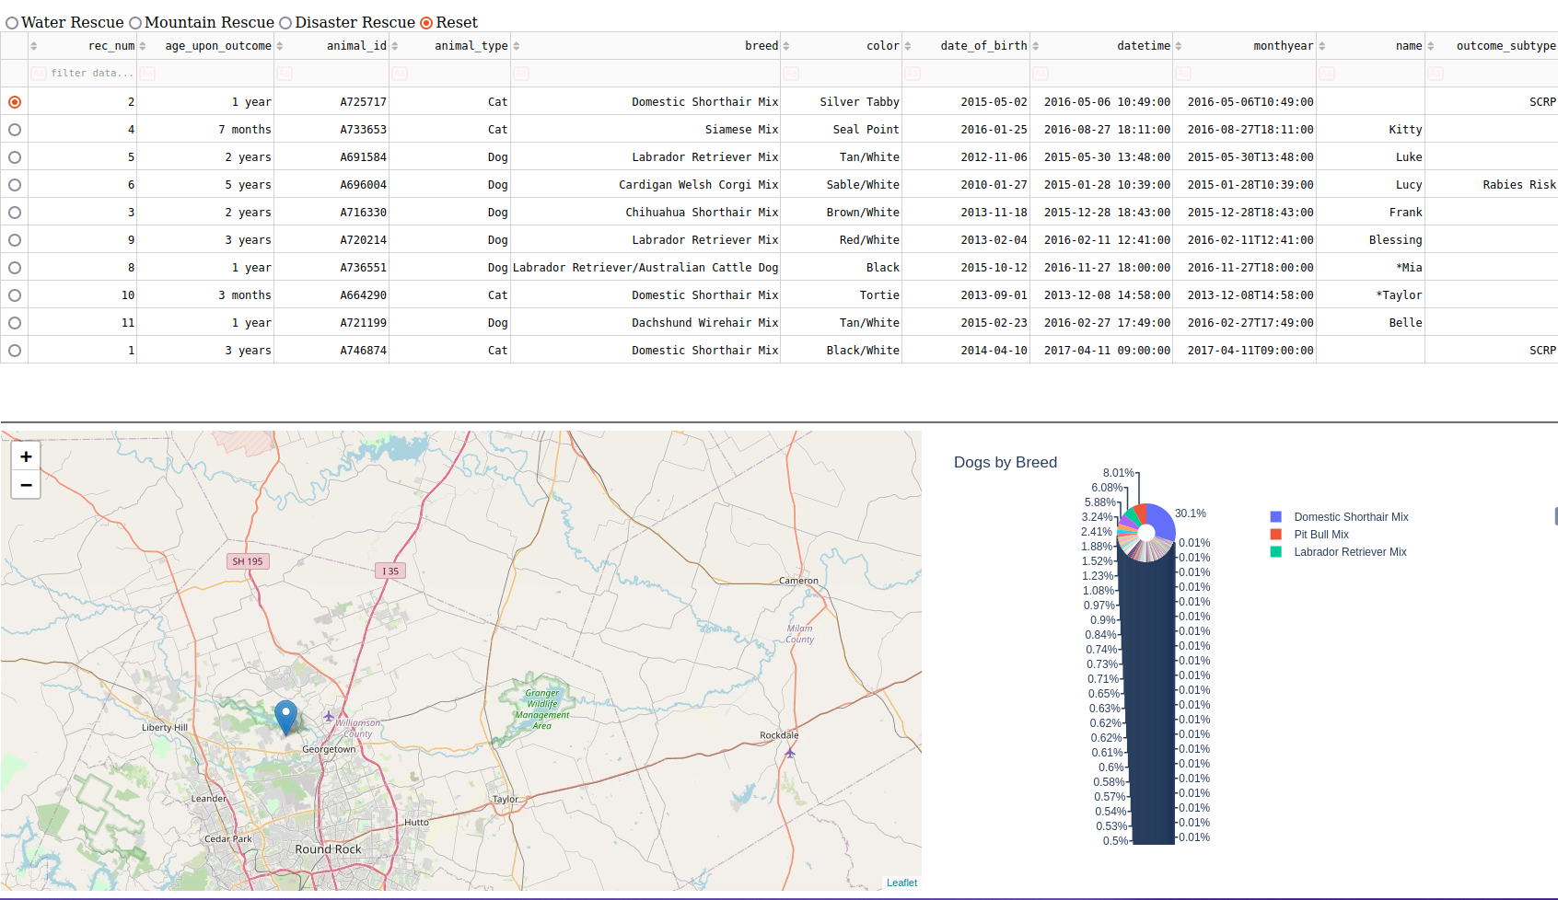

Even when sorting by just Dog breeds

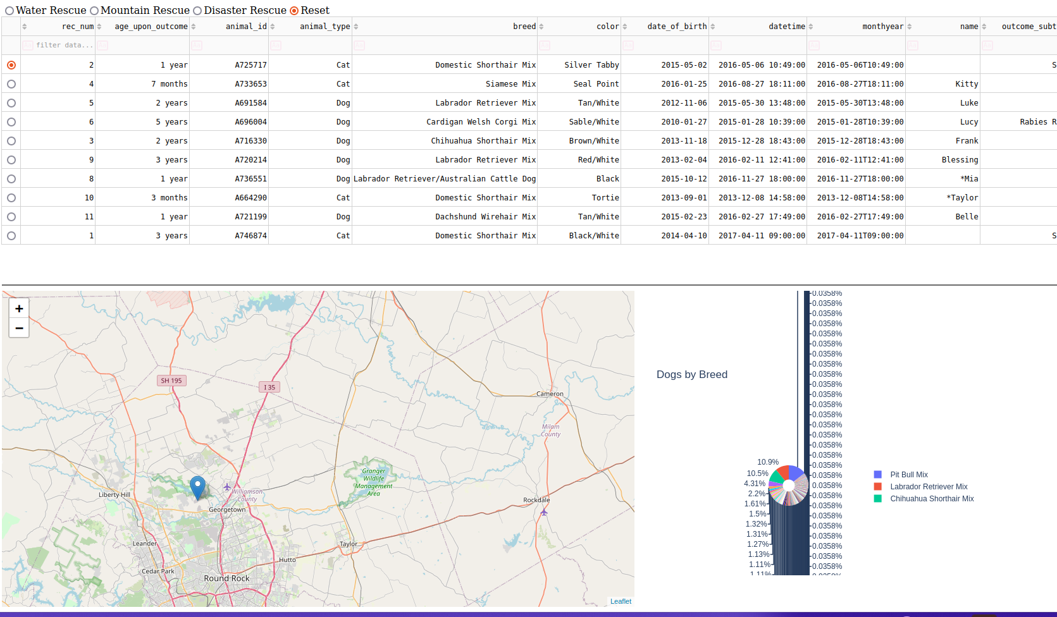

## Contact

Brandon Randall : xxx-xxx-xxxx / brandon.randall1@snhu.edu